CUDA PROGRAM

1.open **google.com**

2.signin to ur **mail**

3.open new tab and go to

[https://colab.research.google.com/notebooks/welcome.ipynb#scrollTo=cPqhK9GsnclA](https://colab.research.google.com/notebooks/welcome.ipynb" \l "scrollTo=cPqhK9GsnclA)

4. click on

* **Runtime ->Change Runtime type**

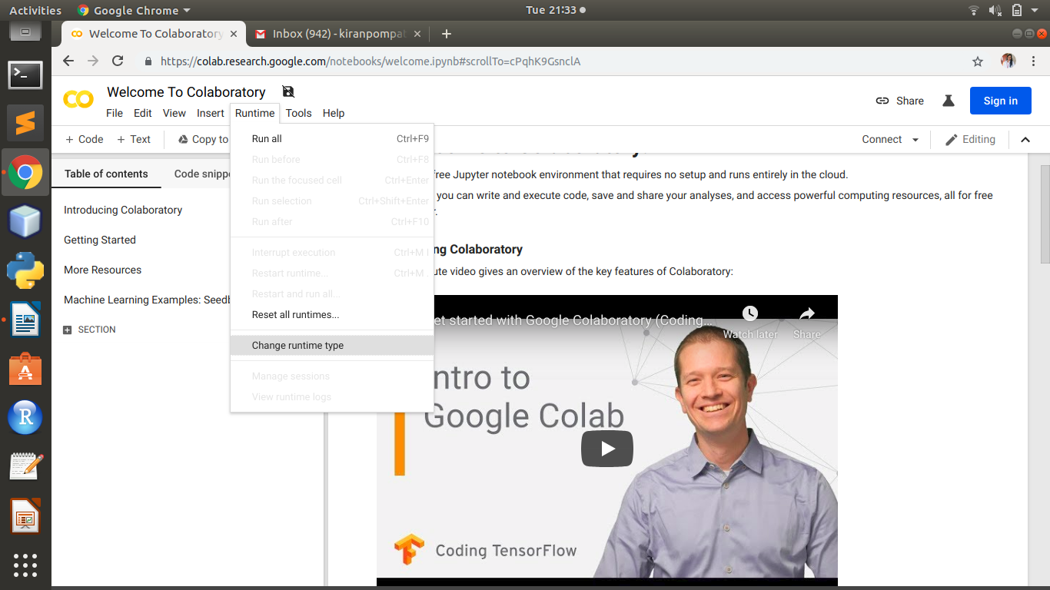

* Select

Runtime type =**python** and

Hardware accelerator =**GPU**

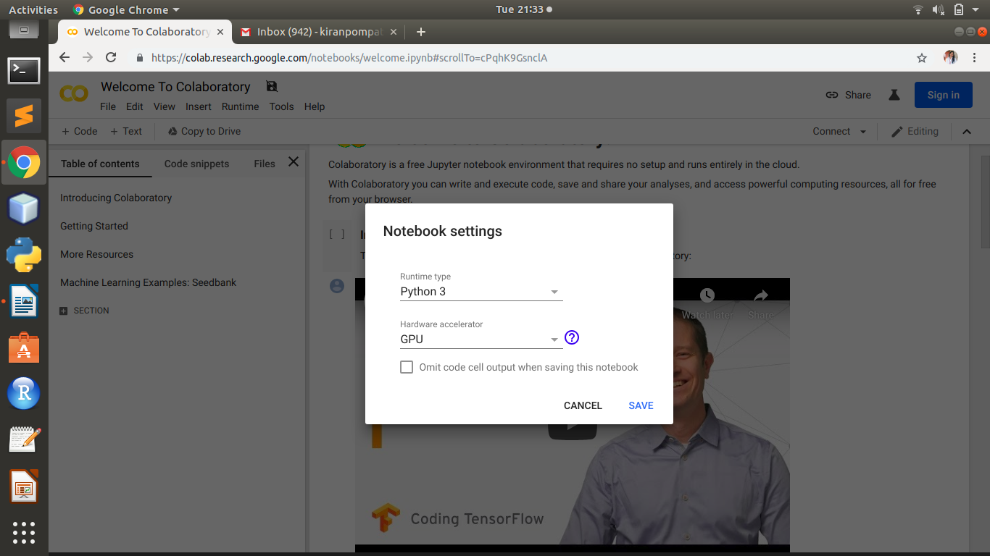

5. Click on

**connect -> connect to hosted runtime** ( u may get popup ->click on leave page)

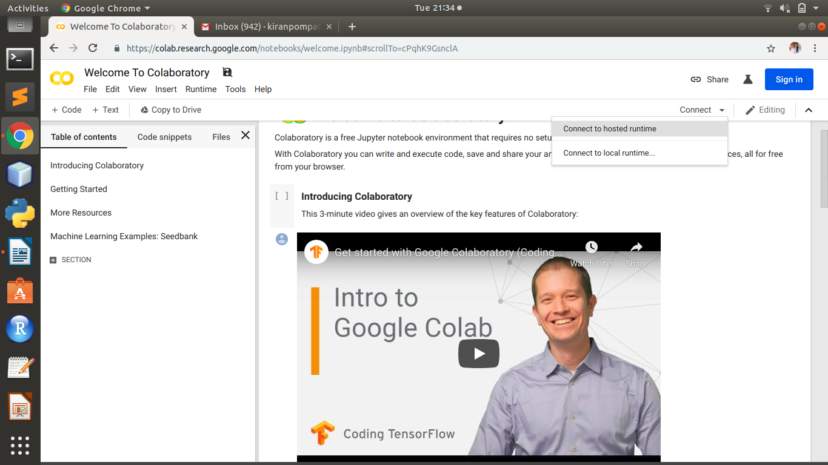

6. click on

**+code**

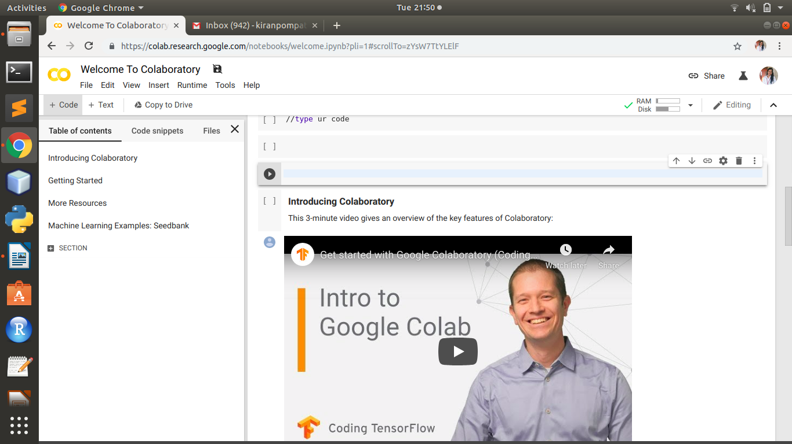

**Type Here**

7.write the following steps:

step 1:- **!/usr/local/cuda/bin/nvcc --version**(click on run cell)

step 2:- click on +code

**!pip install git+git://github.com/andreinechaev/nvcc4jupyter.git**

step 3:- click on +code

**%load_ext nvcc_plugin**

step 4:- click on +code

type ur code (write **%%cu** and **then code**)

